UNITED STATES
SECURITIES AND EXCHANGE COMMISSION
Washington, D.C. 20549
______________________________________
FORM 8-K
______________________________________
CURRENT REPORT
Pursuant to Section 13 or 15(d)
of the Securities Exchange Act of 1934
Date of Report (Date of earliest event reported): August 10, 2026
_________________________________________________
QUANTERIX CORPORATION
(Exact name of registrant as specified in its charter)
_________________________________________________
Delaware |  |  | 001-38319 |  |  | 20-8957988
(State or other jurisdiction  of incorporation) |  |  | (Commission File Number) |  |  | (IRS Employer  Identification No.)
900 Middlesex Turnpike
Billerica, MA |  |  | 01821
(Address of principal executive offices) |  |  | (Zip Code)
(617) 301-9400
(Registrant’s telephone number, including area code)
Check the appropriate box below if the Form 8-K filing is intended to simultaneously satisfy the filing obligation of the registrant under any of the following provisions:

o Written communications pursuant to Rule 425 under the Securities Act (17 CFR 230.425)
o Soliciting material pursuant to Rule 14a-12 under the Exchange Act (17 CFR 240.14a-12)
o Pre-commencement communications pursuant to Rule 14d-2(b) under the Exchange Act (17 CFR 240.14d-2(b))
o Pre-commencement communications pursuant to Rule 13e-4(c) under the Exchange Act (17 CFR 240.13e-4(c))
Securities registered pursuant to Section 12(b) of the Act:
Title of each class: |  |  |  |  |  | Trading symbol(s): |  |  |  |  |  | Name of each exchange on which  registered:
Common Stock, $0.001 par value per share |  |  |  |  |  | QTRX |  |  |  |  |  | The Nasdaq Global Market
Indicate by check mark whether the registrant is an emerging growth company as defined in Rule 405 of the Securities Act of 1933 (17 CFR §230.405) or Rule 12b-2 of the Securities Exchange Act of 1934 (17 CFR §240.12b-2).
Emerging Growth Company o
If an emerging growth company, indicate by check mark if the registrant has elected not to use the extended transition period for complying with any new or revised financial accounting standards provided pursuant to Section 13(a) of the Exchange Act. o

Item 2.02 Results of Operations and Financial Condition.
On August 10, 2026, Quanterix Corporation (“Quanterix”) issued a press release announcing its financial results for it's second fiscal quarter ended June 30, 2026 (the “Earnings Release”). A copy of the Earnings Release is furnished as Exhibit 99.1 and is incorporated herein by reference.
The information in this Item 2.02 of this Form 8-K (including Exhibits 99.1 and 99.2) shall not be deemed “filed” for purposes of Section 18 of the Securities Exchange Act of 1934 (the “Exchange Act”) or otherwise subject to the liabilities of that section, nor shall it be deemed incorporated by reference in any filing under the Securities Act of 1933 (the "Securities Act") or the Exchange Act, except as expressly set forth by specific reference in such a filing.

Item 7.01 Regulation FD Disclosure.
A copy of slides to be presented during Quanterix’s earnings call on August 10, 2026 is furnished as Exhibit 99.2 and is incorporated herein by reference.
On August 10, 2026, Quanterix issued a press release announcing the appointment of Jim Gute as Quanterix’s Chief Commercial Officer. A copy of this press release is furnished as Exhibit 99.3 and is incorporated herein by reference.
The information in Exhibits 99.1, 99.2 and 99.3 shall not be deemed “filed” for purposes of Section 18 of the Exchange Act or otherwise subject to the liabilities of that section, nor shall it be deemed incorporated by reference in any filing under the Securities Act or the Exchange Act, except as expressly set forth by specific reference in such a filing.

Item 9.01 Financial Statements and Exhibits.
(d)Exhibits
Exhibit  No. |  |  |  |  |  | Description
99.1 |  |  |  |  |  | Earnings Release dated August 10, 2026
99.2 |  |  |  |  |  | Slides from August 10, 2026 Earnings Call
99.3 |  |  |  |  |  | Press Release dated August 10, 2026
104 |  |  |  |  |  | Cover Page Interactive Data File (embedded within the inline XBRL document)

SIGNATURES
Pursuant to the requirements of the Securities Exchange Act of 1934, the Registrant has duly caused this report to be signed on its behalf by the undersigned thereunto duly authorized.
 |  |  | QUANTERIX CORPORATION
 |  |  | By: |  |  | /s/ Jason Faessler
 |  |  |  |  |  | Jason Faessler
 |  |  |  |  |  | Chief Financial Officer
Date: August 10, 2026

Exhibit 99.1

Quanterix Releases Financial Results for the Second Quarter of 2026
Reports $32.9 million in revenue and $96.9 million of cash and marketable securities
Company accelerating initiatives to drive commercial effectiveness
Revises financial outlook for 2026 and extends date for attaining cash-flow break-even
BILLERICA, Mass. – August 10, 2026 -- Quanterix Corporation (NASDAQ: QTRX), a global leader in precision biomarker science, today announced financial results for the second quarter ended June 30, 2026.
“We made meaningful progress in the second quarter, including strengthening our leadership team and preserving cash better than planned. However, revenue fell short of our expectations, driven by execution challenges and continued market softness. We are taking immediate and significant action to improve commercial performance, including reorganizing our teams and adding seasoned leadership to sharpen accountability, accelerate execution, and improve operating results in the second half and beyond,” said Everett Cunningham, President & CEO of Quanterix. “We remain confident in the strength and differentiated positioning of both our research tools and diagnostics businesses, especially with enhanced commercial leadership and discipline enabling a renewed focus on returning to sustained growth. Our capabilities in ultra-sensitive protein-detection in blood and high plex spatial analysis in tissue, combined with a differentiated multi-analyte approach, position us well across targeted translational research and diagnostics. With strategic Diagnostics investments underway, our management team can now focus on achieving key milestones in Alzheimer’s disease testing, including completing three clinical utility studies and advancing our FDA roadmap.”

Second Quarter Financial Highlights
•Revenue of $32.9 million, an increase of 34% compared to $24.5 million in the prior year.
•GAAP gross margin of 38.5%, as compared to 40.9% in the prior year. Adjusted gross margin (non-GAAP) of 47.9% compared to 41.8% in the prior year. Prior year GAAP margins are updated to reflect a change in accounting policy in Q1’26 related to shipping and handling costs. Shipping and handling costs for product sales are now recorded in the cost of product revenue in the Company’s GAAP financials.
•Adjusted EBITDA (non-GAAP) loss of $10.0 million, compared to $13.7 million in the prior year.
•The Company ended the second quarter with $96.9 million of cash, cash equivalents, marketable securities, and restricted cash. Adjusted cash usage, after accounting for integration and certain employee separation costs of $1.7 million, was $4.0 million in the second quarter, a decrease in usage of $10.8 million from the first quarter of 2026.
•The Company completed its ERP system integration, the final step of the Akoya acquisition integration program that realized $85 million in savings on an annualized basis.
•Quanterix incurred a $26.9 million goodwill impairment related to the Akoya acquisition as required under GAAP accounting based on recent circumstances within the business. The adjustment does not impact operations or liquidity.

Operational and Business Highlights
•Quanterix finished building its senior management team ahead of its anticipated higher growth phase, especially in the Diagnostics business. Jim Gute was named Chief Commercial Officer, as announced separately today. Industry veteran Geoff Albrecht was appointed Senior Vice President and General Manager of Diagnostics, Anthony Catalano was named Chief Operating Officer and Jason Faessler was appointed Chief Financial Officer.
•Several milestones to advance clinical adoption of blood-based Alzheimer’s testing were announced, including commercial insurance coverage. Beginning July 1, 2026, members covered under Anthem Blue Cross and Blue Shield medical policies can receive coverage for qualifying blood-based biomarker testing, including Quanterix’s Lucent AD® Complete, when medical necessity criteria are met.
•A peer-reviewed study evaluating Lucent AD® Complete alongside an algorithmic immunoprecipitation mass spectrometry (IP-MS) approach on a shared patient cohort demonstrated the high diagnostic parity and three-fold reduced diagnostic ambiguity provided by Quanterix’s multi-analyte algorithmic blood testing approach.

•New clinical data presented at the Alzheimer’s Association International Conference (AAIC) 2026 highlighted how multi-biomarker testing improves detection of early Alzheimer's and provides a more comprehensive framework for guiding patient care.
•Quanterix was selected as a Co-Investigator institution in the PD-BUILD program, in the Aligning Science Across Parkinson’s Collaborative Research Network 2026 expansion, supported by The Michael J. Fox Foundation. This multi-year grant funds development and deployment of high-quality biomarker tools aimed at enabling earlier detection, improved patient stratification, and more effective monitoring of Parkinson’s disease in clinical research. Quanterix and its Simoa platform will develop and distribute validated single-plex and multiplex biomarker assays to Parkinson’s disease researchers globally.
•Quanterix launched Simoa® Ultra-Sensitive Immunoassay NPTX2, an important emerging synaptic biomarker.
•Two new spatial products were launched: Spatial Molecular Barcoding kit for the Phenocycler Fusion for early access and Spatial Spectral DAPI 2.0 for the Phenoimager HT.

2026 Business Outlook
Quanterix currently expects revenues of $142-148 million, which assumes no underlying improvement in the academic or pharmaceutical end markets, compared to its earlier expectation for annual revenues of $169-174 million. In addition, we expect non-GAAP gross margins in a range of 48-50%, compared to non-GAAP gross margins of 49-53% previously. Quanterix now anticipates achieving cash flow breakeven in 2027 but is currently forecasting approximately $80 million for the 2026 year-end cash balance, compared to $100 million previously. The company expects to end the year with no debt.

Conference Call
In conjunction with this announcement, the Company will host a conference call today, August 10, 2026, at 8:30 AM ET. The dial-in number for USA & Canada is Toll-Free (800) 715-9871 or (646) 307-1963 and the conference ID is 9896910.
Interested investors can also listen to the live webcast from the Event Details page in the Investors section of the Quanterix website at https://ir.quanterix.com. An archived webcast replay will be available on the Company’s website for one year.
About Quanterix
Quanterix is a global leader in precision biomarker science, making biology measurable to deliver earlier insights and support breakthroughs in disease research, diagnostics, and drug development. Its Simoa® technology delivers industry-leading sensitivity, allowing researchers to detect and quantify biomarkers in blood and other fluids at concentrations far below traditional limits. Through the acquisition of Akoya Biosciences, Quanterix Spatial solutions deliver high-plex, quantitative protein analysis in tissue at single-cell resolution. Combined with Accelerator Laboratory services, Quanterix gives researchers the tools and expertise to translate discovery into precision diagnostics. Learn more at www.quanterix.com.

CAUTIONARY STATEMENT REGARDING FORWARD-LOOKING STATEMENTS
Statements included in this press release that are not historical in nature or do not relate to current facts are intended to be, and are hereby identified as, forward-looking statements for purposes of the safe harbor provided by Section 27A of the Securities Act of 1933, as amended, and Section 21E of the Securities Exchange Act of 1934, as amended. Forward-looking statements include, among other things, statements about Quanterix’s future business outlook, operations, strategy and financial performance, including statements related to our expectations about consistent profitable revenue growth and achieving cash flow breakeven performance, the development and commercialization of our products, and under the header “2026 Business Outlook.”. Words and phrases such as “may,” “approximately,” “continue,” “should,” “expects,” “projects,” “anticipates,” “is likely,” “look ahead,” “look forward,” “believes,” “will,” “intends,” “estimates,” “strategy,” “plan,” “could,” “potential,” “possible” and variations of such words and similar expressions are intended to identify such forward-looking statements. Forward-looking statements are subject to certain risks and uncertainties that are difficult to predict with regard to, among other things, timing, extent, likelihood and degree of occurrence, which could cause actual results to differ materially from anticipated results. Such risks and uncertainties include, among others, the following possibilities with respect to Quanterix’s future business, operations, strategy and financial performance: risks related to the impact of changes in U.S. government policies, including impacts of tariffs and reductions in federal research funding; risks associated with the anticipated timing for launch of, and features of, Quanterix’s next-generation instruments to

upgrade its existing platforms; risks related to Quanterix’s ability to improve existing diagnostics and develop new diagnostic tests and tools; risks related to Quanterix’s ability to successfully penetrate the diagnostics market; risks related to Quanterix’s ability to retain and expand its customer base and achieve sufficient market acceptance of its products; risks related to the ability of Quanterix’s contract manufacturers and suppliers to reliably and consistently manufacture and supply our instruments; risks that Quanterix may fail to realize the anticipated benefits from its recent acquisitions of Emission, Inc. and Akoya Biosciences, Inc.; risks that Quanterix’s estimates regarding expenses, future revenues, capital requirements, and needs for additional financing could be incorrect; risks related to Quanterix’s ability to maintain effective internal control over financial reporting and disclosure controls and procedures; and risks related to defects or other quality issues in Quanterix’s products that could lead to unforeseen costs, product recalls, adverse regulatory actions, negative publicity and litigation. Additional factors that could cause results to differ materially from those described above can be found in the periodic reports filed by Quanterix with the SEC, including the “Risk Factors” sections contained therein, which are available on the SEC’s website at www.sec.gov.
All forward-looking statements, expressed or implied, included in this press release are expressly qualified in their entirety by the cautionary statements contained or referred to herein. If one or more events related to these or other risks or uncertainties materialize, or if Quanterix’s underlying assumptions prove to be incorrect, actual results may differ materially from what Quanterix anticipates. Quanterix cautions readers not to place undue reliance on any such forward-looking statements, which speak only as of the date they are made and are based on information available at that time. Quanterix does not assume any obligation to update or otherwise revise any forward-looking statements to reflect circumstances or events that occur after the date the forward-looking statements were made or to reflect the occurrence of unanticipated events except as required by federal securities laws.

FINANCIAL HIGHLIGHTS

QUANTERIX CORPORATION
CONSOLIDATED STATEMENTS OF OPERATIONS
(unaudited, amounts in thousands, except per share data)
 |  |  | Three Months Ended June 30, |  |  |  |  |  |  |  |  |  |  |  | Six Months Ended June 30,
 |  |  | 2026 |  |  |  |  |  | 2025 |  |  |  |  |  | 2026 |  |  |  |  |  | 2025
Revenues:
Product revenue |  |  | $ | 23,476 |  |  |  |  | $ | 16,832 |  |  |  |  | $ | 48,956 |  |  |  |  | $ | 37,572
Service and other revenue |  |  | 9,018 |  |  |  |  |  | 7,112 |  |  |  |  |  | 19,394 |  |  |  |  |  | $ | 15,935
Collaboration and license revenue |  |  | 412 |  |  |  |  |  | 532 |  |  |  |  |  | 972 |  |  |  |  |  | $ | 1,303
Total revenues |  |  | 32,906 |  |  |  |  |  | 24,476 |  |  |  |  |  | 69,322 |  |  |  |  |  | 54,810
Costs of goods sold and services:
Cost of product revenue |  |  | 14,621 |  |  |  |  |  | 10,594 |  |  |  |  |  | 29,761 |  |  |  |  |  | $ | 21,935
Cost of service and other revenue |  |  | 5,611 |  |  |  |  |  | 3,881 |  |  |  |  |  | 11,320 |  |  |  |  |  | $ | 8,035
Total costs of goods sold and services |  |  | 20,232 |  |  |  |  |  | 14,475 |  |  |  |  |  | 41,081 |  |  |  |  |  | 29,970
Gross profit |  |  | 12,674 |  |  |  |  |  | 10,001 |  |  |  |  |  | 28,241 |  |  |  |  |  | 24,840
Operating expenses:
Research and development |  |  | 7,821 |  |  |  |  |  | 9,081 |  |  |  |  |  | 15,144 |  |  |  |  |  | 19,117
Selling, general and administrative |  |  | 27,350 |  |  |  |  |  | 30,350 |  |  |  |  |  | 57,121 |  |  |  |  |  | 61,520
Impairment and restructuring costs |  |  | 26,934 |  |  |  |  |  | 7,670 |  |  |  |  |  | 46,769 |  |  |  |  |  | 7,670
Total operating expenses |  |  | 62,105 |  |  |  |  |  | 47,101 |  |  |  |  |  | 119,034 |  |  |  |  |  | 88,307
Loss from operations |  |  | (49,431) |  |  |  |  |  | (37,100) |  |  |  |  |  | (90,793) |  |  |  |  |  | (63,467)
Other income (expense), net:
Interest income |  |  | 761 |  |  |  |  |  | 2,692 |  |  |  |  |  | 1,653 |  |  |  |  |  | 5,962
Change in fair value of contingent liabilities |  |  | (79) |  |  |  |  |  | 4,273 |  |  |  |  |  | 1,422 |  |  |  |  |  | 3,894
Other income (expense), net |  |  | (239) |  |  |  |  |  | 49 |  |  |  |  |  | 21,182 |  |  |  |  |  | 108
Loss before income taxes |  |  | (48,988) |  |  |  |  |  | (30,086) |  |  |  |  |  | (66,536) |  |  |  |  |  | (53,503)
Income tax benefit |  |  | 54 |  |  |  |  |  | 73 |  |  |  |  |  | 61 |  |  |  |  |  | 2,986
Net loss |  |  | $ | (48,934) |  |  |  |  | $ | (30,013) |  |  |  |  | $ | (66,475) |  |  |  |  | $ | (50,517)
Net loss per common share, basic and diluted |  |  | $ | (1.04) |  |  |  |  | $ | (0.77) |  |  |  |  | $ | (1.41) |  |  |  |  | $ | (1.30)
Weighted-average common shares outstanding, basic and diluted |  |  | 47,167 |  |  |  |  |  | 38,893 |  |  |  |  |  | 47,068 |  |  |  |  |  | 38,801

QUANTERIX CORPORATION
CONSOLIDATED BALANCE SHEETS
(unaudited, amounts in thousands, except per share data)
 |  |  | June 30, 2026 |  |  |  |  |  | December 31, 2025
ASSETS
Current assets:
Cash and cash equivalents |  |  | $ | 44,169 |  |  |  |  | $ | 29,839
Marketable securities |  |  | 49,360 |  |  |  |  |  | 88,393
Accounts receivable, net of allowance for expected credit losses |  |  | 22,345 |  |  |  |  |  | 29,972
Inventory |  |  | 47,601 |  |  |  |  |  | 54,763
Prepaid expenses and other current assets |  |  | 7,576 |  |  |  |  |  | 9,290
Total current assets |  |  | 171,051 |  |  |  |  |  | 212,257
Restricted cash |  |  | 3,348 |  |  |  |  |  | 3,341
Property and equipment, net |  |  | 20,002 |  |  |  |  |  | 23,672
Intangible assets, net |  |  | 105,782 |  |  |  |  |  | 131,787
Goodwill |  |  | — |  |  |  |  |  | 26,376
Operating lease right-of-use assets |  |  | 15,053 |  |  |  |  |  | 16,664
Other non-current assets |  |  | 4,391 |  |  |  |  |  | 4,669
Total assets |  |  | $ | 319,627 |  |  |  |  | $ | 418,766
LIABILITIES AND STOCKHOLDERS' EQUITY
Current liabilities:
Accounts payable |  |  | $ | 8,892 |  |  |  |  | $ | 13,568
Accrued compensation and benefits |  |  | 10,293 |  |  |  |  |  | 14,979
Accrued expenses and other current liabilities |  |  | 8,483 |  |  |  |  |  | 17,571
Deferred revenue |  |  | 14,892 |  |  |  |  |  | 20,728
Operating lease liabilities |  |  | 7,813 |  |  |  |  |  | 7,916
Total current liabilities |  |  | 50,373 |  |  |  |  |  | 74,762
Deferred revenue, net of current portion |  |  | 2,502 |  |  |  |  |  | 5,830
Operating lease liabilities, net of current portion |  |  | 25,574 |  |  |  |  |  | 29,323
Non-current portion of contingent liabilities |  |  | 3,265 |  |  |  |  |  | 5,024
Other non-current liabilities |  |  | 701 |  |  |  |  |  | 8,097
Total liabilities |  |  | 82,415 |  |  |  |  |  | 123,036
Total stockholders’ equity |  |  | 237,212 |  |  |  |  |  | 295,730
Total liabilities and stockholders’ equity |  |  | $ | 319,627 |  |  |  |  | $ | 418,766

QUANTERIX CORPORATION
CONSOLIDATED STATEMENTS OF CASH FLOWS
(unaudited, amounts in thousands)
 |  |  | Six Months Ended June 30,
 |  |  | 2026 |  |  |  |  |  | 2025
Cash flows from operating activities:
Net loss |  |  | $ | (66,475) |  |  |  |  | $ | (50,517)
Adjustments to reconcile net loss to net cash used in operating activities:
Depreciation and amortization expense |  |  | 11,737 |  |  |  |  |  | 4,187
Credit losses on accounts receivable |  |  | 516 |  |  |  |  |  | (262)
Accretion of marketable securities |  |  | (202) |  |  |  |  |  | (1,567)
Operating lease right-of-use asset amortization |  |  | 1,601 |  |  |  |  |  | 850
Stock-based compensation expense |  |  | 8,739 |  |  |  |  |  | 10,834
Impairment |  |  | 46,769 |  |  |  |  |  | 6,374
Change in fair value of contingent liabilities |  |  | (1,422) |  |  |  |  |  | (3,894)
Recognition of off-market liability |  |  | (13,975) |  |  |  |  |  | —
Other operating activity |  |  | (558) |  |  |  |  |  | (370)
Changes in assets and liabilities:
Accounts receivable |  |  | 6,817 |  |  |  |  |  | 9,476
Inventory |  |  | 7,652 |  |  |  |  |  | 2,993
Prepaid expenses and other current assets |  |  | 1,561 |  |  |  |  |  | 1,942
Accounts payable |  |  | (6,763) |  |  |  |  |  | 2,796
Accrued compensation and benefits, accrued expenses, and other current liabilities |  |  | (6,377) |  |  |  |  |  | 1,605
Deferred revenue |  |  | (9,163) |  |  |  |  |  | 583
Net change in other operating assets and liabilities |  |  | (3,683) |  |  |  |  |  | (4,573)
Net cash used in operating activities |  |  | (23,226) |  |  |  |  |  | (19,543)
Cash flows from investing activities:
Purchases of marketable securities |  |  | (8,245) |  |  |  |  |  | (30,245)
Proceeds from sales and maturities of marketable securities |  |  | 47,354 |  |  |  |  |  | 135,874
Purchases of property and equipment |  |  | (183) |  |  |  |  |  | (2,033)
Acquisitions, net of cash acquired |  |  | — |  |  |  |  |  | (8,954)
Net cash provided by investing activities |  |  | 38,926 |  |  |  |  |  | 94,642
Cash flows from financing activities:
Deferred acquisition payments |  |  | (1,439) |  |  |  |  |  | —
Principal payments on financing leases |  |  | (171) |  |  |  |  |  | —
Proceeds from common stock issued under stock plans |  |  | 340 |  |  |  |  |  | 668
Payments for employee taxes withheld on stock-based compensation awards |  |  | (27) |  |  |  |  |  | (1,004)
Net cash used in financing activities |  |  | (1,297) |  |  |  |  |  | (336)
Net increase in cash, cash equivalents, and restricted cash |  |  | 14,403 |  |  |  |  |  | 74,763
Effect of exchange rate changes on cash, cash equivalents, and restricted cash |  |  | (66) |  |  |  |  |  | 1,455
Cash, cash equivalents, and restricted cash at beginning of period |  |  | 33,180 |  |  |  |  |  | 59,319
Cash, cash equivalents, and restricted cash at end of period |  |  | $ | 47,517 |  |  |  |  | $ | 135,537

Use of Non-GAAP Financial Measures
To supplement our financial statements presented on a U.S. GAAP basis, we present the following non-GAAP financial measures:
•Adjusted EBITDA and adjusted EBITDA margin: We define adjusted EBITDA as net income (loss) adjusted to exclude interest income, income tax (expense) benefit, depreciation and amortization expense, stock-based compensation expense, acquisition and integration related costs, impairments, and certain other items which include other charges or benefits resulting from transactions or events that are unusual or infrequent, significant in size, and that we do not believe are indicative of ongoing or future business operations. These items are discussed in more detail below the tables reconciling the GAAP to non-GAAP measures. Adjusted EBITDA margin is calculated as adjusted EBITDA divided by total revenues.
•Adjusted cash usage: We calculate cash usage as the total change in cash, cash equivalents, and restricted cash adjusted to include the net change from purchases, sales, and maturities of marketable securities (excluding any interest receivable). Adjusted cash usage is calculated as cash usage further adjusted to exclude cash payments related to transactions or events that are unusual or infrequent, significant in size, and that we do not believe are indicative of ongoing or future business operations.
•Adjusted gross profit, adjusted gross margin, adjusted total operating expenses, and adjusted loss from operations: We calculate these non-GAAP financial measures by excluding amortization of certain acquired intangible assets, acquisition and integration related costs, impairments, and certain other items which include other charges or benefits resulting from transactions or events that are unusual or infrequent, significant in size, and that we do not believe are indicative of ongoing or future business operations. Adjusted gross margin is calculated as adjusted gross profit divided by total revenues.
During the first quarter of 2026, we changed our accounting policy for classifying shipping and handling costs for product sales and they are now recorded in cost of product revenue. Historically, these shipping and handling costs were recorded in selling, general and administrative expenses, and we calculated our non-GAAP financial measures by including these shipping and handling costs within cost of product revenue. We applied this change in accounting policy retrospectively to all periods presented, and no longer reclassify shipping and handling costs in our non-GAAP financial measures.
We believe that presentation of these non-GAAP financial measures provides supplemental information useful to investors in understanding our underlying operating results and trends. We use these non-GAAP financial measures to evaluate our operating performance in a manner that allows for meaningful period-to-period comparison and analysis of trends in our business and our competitors. We believe that presentation of these non-GAAP financial measures provides useful information to investors in assessing our operating performance within our industry and allows comparability with the presentation of other companies in our industry.
The non-GAAP financial measures presented here should be considered in conjunction with, and not as a substitute for, the financial information presented in accordance with U.S. GAAP. For example, adjusted EBITDA excludes a number of expense items that are included in net loss and adjusted cash usage excludes certain actual cash payments. As a result, positive adjusted EBITDA or positive adjusted cash usage may be achieved even where we record a significant net loss or reduction in our cash and marketable securities balances in accordance with U.S. GAAP.
Investors are encouraged to review the reconciliation of these non-GAAP financial measures to their most directly comparable GAAP financial measures set forth in the tables captioned “Reconciliations of GAAP to Non-GAAP Financial Measures” in the section below.
Additionally, we make certain forward-looking statements about our future financial performance that include non-GAAP financial measures, which are difficult to predict for future periods because the nature of the adjustments pertains to events that have not yet occurred. We do not forecast many of the excluded items for internal use and therefore information reconciling forward-looking non-GAAP financial measures to U.S. GAAP financial measures is not available without unreasonable effort and is not provided. The occurrence, timing, and amount of any of the items excluded from U.S. GAAP to calculate non-GAAP financial measures could significantly impact our U.S. GAAP results.

QUANTERIX CORPORATION
RECONCILIATIONS OF GAAP TO NON-GAAP FINANCIAL MEASURES

Reconciliation of Net Loss to Adjusted EBITDA (non-GAAP) and Adjusted EBITDA Margin (non-GAAP)
(unaudited, amounts in thousands, except percentages)

 |  |  | Three Months Ended June 30, |  |  |  |  |  |  |  |  |  |  |  | Six Months Ended June 30,
 |  |  | 2026 |  |  |  |  |  | 2025 |  |  |  |  |  | 2026 |  |  |  |  |  | 2025
Net loss |  |  | $ | (48,934) |  |  |  |  | $ | (30,013) |  |  |  |  | $ | (66,475) |  |  |  |  | $ | (50,517)
Interest income |  |  | (761) |  |  |  |  |  | (2,692) |  |  |  |  |  | (1,653) |  |  |  |  |  | (5,962)
Income tax benefit |  |  | (54) |  |  |  |  |  | (73) |  |  |  |  |  | (61) |  |  |  |  |  | (2,986)
Depreciation and amortization |  |  | 6,134 |  |  |  |  |  | 1,999 |  |  |  |  |  | 11,737 |  |  |  |  |  | 4,187
Stock-based compensation expense (1) |  |  | 4,212 |  |  |  |  |  | 5,373 |  |  |  |  |  | 8,388 |  |  |  |  |  | 10,834
Acquisition and integration related costs (2) |  |  | 852 |  |  |  |  |  | 4,139 |  |  |  |  |  | 2,004 |  |  |  |  |  | 7,717
Earnout recorded as compensation expense (3) |  |  | — |  |  |  |  |  | 4,156 |  |  |  |  |  | — |  |  |  |  |  | 7,900
Changes in contingent liabilities (4) |  |  | 79 |  |  |  |  |  | (4,273) |  |  |  |  |  | (1,422) |  |  |  |  |  | (3,894)
Impairment and employee separation costs (5) |  |  | 28,483 |  |  |  |  |  | 7,670 |  |  |  |  |  | 49,271 |  |  |  |  |  | 7,670
Income from contract termination (6) |  |  | — |  |  |  |  |  | — |  |  |  |  |  | (21,596) |  |  |  |  |  | —
Adjusted EBITDA (non-GAAP) |  |  | $ | (9,989) |  |  |  |  | $ | (13,714) |  |  |  |  | $ | (19,807) |  |  |  |  | $ | (25,051)
Total revenues |  |  | $ | 32,906 |  |  |  |  | $ | 24,476 |  |  |  |  | $ | 69,322 |  |  |  |  | $ | 54,810
Adjusted EBITDA margin (non-GAAP) (adjusted EBITDA as a % of revenue) |  |  | (30.4) |  | % |  |  |  | (56.0) |  | % |  |  |  | (28.6) |  | % |  |  |  | (45.7) |  | %
(1)Stock-based compensation expense for certain individuals is included in the caption 'Impairment and employee separation costs'.
(2)Represents acquisition and integration costs directly related to the Company's business combinations. Acquisition costs include professional and consulting fees supporting due diligence, legal, and accounting activities to execute a transaction. Integration costs include third party and internal direct costs to integrate acquired companies, employees, and their customers.
(3)Consists of the earnout recognized as compensation expense related to the Emission acquisition.
(4)Consists of fair value adjustments for contingent liabilities from acquisitions.
(5)Impairment charges for goodwill and an intangible asset related to the termination of a diagnostics development agreement assumed in the acquisition of Akoya, as well as certain one-time severance and related costs.
(6)One-time income related to the impact of terminating a diagnostics development agreement assumed in the acquisition of Akoya.

Reconciliation of Gross Profit, Gross Margin, Total Operating Expenses and Loss from Operations to Non-GAAP Financial Measures
(unaudited, amounts in thousands, except percentages)

 |  |  | Three Months Ended June 30, |  |  |  |  |  |  |  |  |  |  |  | Six Months Ended June 30,
 |  |  | 2026 |  |  |  |  |  | 2025 |  |  |  |  |  | 2026 |  |  |  |  |  | 2025
Gross profit |  |  | $ | 12,674 |  |  |  |  | $ | 10,001 |  |  |  |  | $ | 28,241 |  |  |  |  | $ | 24,840
Purchase accounting impact on inventory and property and equipment (1) |  |  | 203 |  |  |  |  |  | — |  |  |  |  |  | 402 |  |  |  |  |  | —
Amortization of acquired intangible assets (2) |  |  | 2,886 |  |  |  |  |  | 234 |  |  |  |  |  | 5,658 |  |  |  |  |  | 461
Adjusted gross profit (non-GAAP) |  |  | $ | 15,763 |  |  |  |  | $ | 10,235 |  |  |  |  | $ | 34,301 |  |  |  |  | $ | 25,301
Total revenues |  |  | $ | 32,906 |  |  |  |  | $ | 24,476 |  |  |  |  | $ | 69,322 |  |  |  |  | $ | 54,810
Gross margin (gross profit as % of total revenues) |  |  | 38.5% |  |  |  |  |  | 40.9% |  |  |  |  |  | 40.7% |  |  |  |  |  | 45.3%
Adjusted gross margin (non-GAAP) (adjusted gross profit as % of total revenues) |  |  | 47.9% |  |  |  |  |  | 41.8% |  |  |  |  |  | 49.5% |  |  |  |  |  | 46.2%
Total operating expenses |  |  | $ | 62,105 |  |  |  |  | $ | 47,101 |  |  |  |  | $ | 119,034 |  |  |  |  | $ | 88,307
Purchase accounting impact on property and equipment (1) |  |  | (969) |  |  |  |  |  | — |  |  |  |  |  | (1,192) |  |  |  |  |  | —
Amortization of acquired intangible assets (2) |  |  | (50) |  |  |  |  |  | — |  |  |  |  |  | (127) |  |  |  |  |  | —
Acquisition and integration related costs (3) |  |  | (852) |  |  |  |  |  | (4,139) |  |  |  |  |  | (2,004) |  |  |  |  |  | (7,717)
Earnout recorded as compensation expense (4) |  |  | — |  |  |  |  |  | (4,156) |  |  |  |  |  | — |  |  |  |  |  | (7,900)
Impairment and employee separation costs (5) |  |  | (28,484) |  |  |  |  |  | (7,670) |  |  |  |  |  | (49,270) |  |  |  |  |  | (7,670)
Adjusted total operating expenses (non-GAAP) |  |  | $ | 31,750 |  |  |  |  | $ | 31,136 |  |  |  |  | $ | 66,441 |  |  |  |  | $ | 65,020
Loss from operations |  |  | $ | (49,431) |  |  |  |  | $ | (37,100) |  |  |  |  | $ | (90,793) |  |  |  |  | $ | (63,467)
Purchase accounting impact on inventory and property and equipment (1) |  |  | 1,172 |  |  |  |  |  | — |  |  |  |  |  | 1,594 |  |  |  |  |  | —
Amortization of acquired intangible assets (2) |  |  | 2,936 |  |  |  |  |  | 234 |  |  |  |  |  | 5,785 |  |  |  |  |  | 461
Acquisition and integration related costs (3) |  |  | 852 |  |  |  |  |  | 4,139 |  |  |  |  |  | 2,004 |  |  |  |  |  | 7,717
Earnout recorded as compensation expense (4) |  |  | — |  |  |  |  |  | 4,156 |  |  |  |  |  | — |  |  |  |  |  | 7,900
Impairment and employee separation costs (5) |  |  | 28,484 |  |  |  |  |  | 7,670 |  |  |  |  |  | 49,270 |  |  |  |  |  | 7,670
Adjusted loss from operations (non-GAAP) |  |  | $ | (15,987) |  |  |  |  | $ | (20,901) |  |  |  |  | $ | (32,140) |  |  |  |  | $ | (39,719)
(1)Represents amortization of the purchase price fair value increase of acquired inventory and property and equipment.
(2)Consists only of the amortization of intangible assets acquired in 2025.
(3)Represents acquisition and integration costs directly related to the Company's business combinations. Acquisition costs include professional and consulting fees supporting due diligence, legal, and accounting activities to execute a transaction. Integration costs include third party and internal direct costs to integrate acquired companies, employees, and their customers.
(4)Consists of the earnout recognized as compensation expense related to the Emission acquisition.
(5)Impairment charges for goodwill and an intangible asset related to the termination of a diagnostics development agreement assumed in the acquisition of Akoya, as well as certain one-time severance and related costs.

Reconciliation of Net Increase (Decrease) in Cash, Cash Equivalents, and
Restricted Cash to Adjusted Cash Usage (non-GAAP)
(unaudited, amounts in thousands)

 |  |  | Three Months Ended June 30, |  |  |  |  |  |  |  |  |  |  |  | Six Months Ended June 30,
 |  |  | 2026 |  |  |  |  |  | 2025 |  |  |  |  |  | 2026 |  |  |  |  |  | 2025
Net increase in cash, cash equivalents, and restricted cash |  |  | $ | 8,017 |  |  |  |  | $ | 55,796 |  |  |  |  | $ | 14,403 |  |  |  |  | $ | 74,763
Effect of exchange rate changes on cash, cash equivalents, and restricted cash |  |  | (26) |  |  |  |  |  | 594 |  |  |  |  |  | (66) |  |  |  |  |  | 1,455
Net change in marketable securities |  |  | (13,723) |  |  |  |  |  | (62,093) |  |  |  |  |  | (39,033) |  |  |  |  |  | (104,137)
Cash usage |  |  | (5,732) |  |  |  |  |  | (5,703) |  |  |  |  |  | (24,696) |  |  |  |  |  | (27,919)
Adjustments:
Acquisition and integration related payments (1) |  |  | 1,092 |  |  |  |  |  | 1,987 |  |  |  |  |  | 3,202 |  |  |  |  |  | 14,077
Payment of employee separation costs (2) |  |  | 649 |  |  |  |  |  | 1,073 |  |  |  |  |  | 2,731 |  |  |  |  |  | 1,073
Payments related to restatement costs (3) |  |  | — |  |  |  |  |  | — |  |  |  |  |  | — |  |  |  |  |  | 1,102
Adjusted cash usage (non-GAAP) |  |  | $ | (3,991) |  |  |  |  | $ | (2,643) |  |  |  |  | $ | (18,763) |  |  |  |  | $ | (11,667)
(1)Represents cash payments towards acquisition and integration related activities, including the cash purchase price of an acquired business.
(2)Represents cash payments for certain one-time severance and related costs.
(3)Payment of costs associated with the restatement of previously issued financial statements that was completed at the end of 2024.

Media Contact:
media@quanterix.com
Investor Relations Contact:
ir@quanterix.com
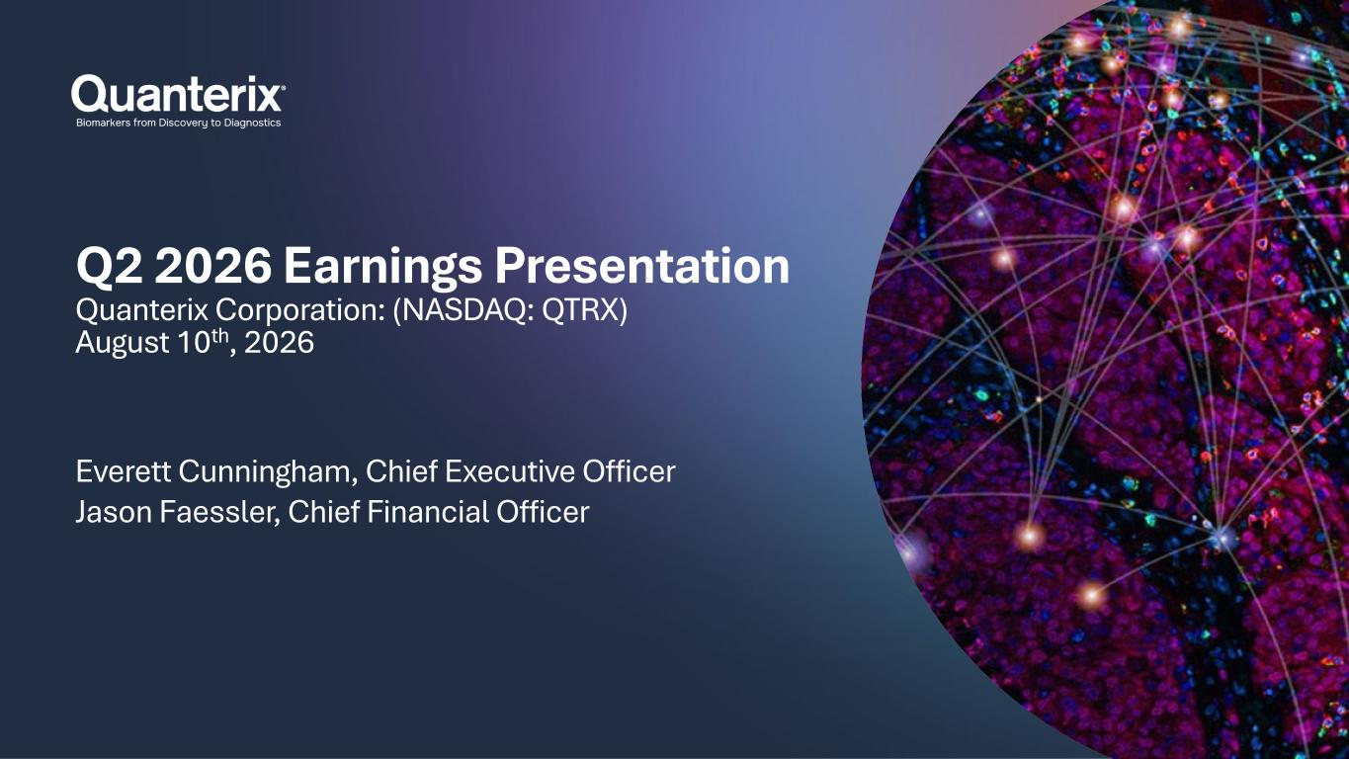

Q2 2026 Earnings Presentation Quanterix Corporation: (NASDAQ: QTRX) August 10th, 2026 Everett Cunningham, Chief Executive Officer Jason Faessler, Chief Financial Officer

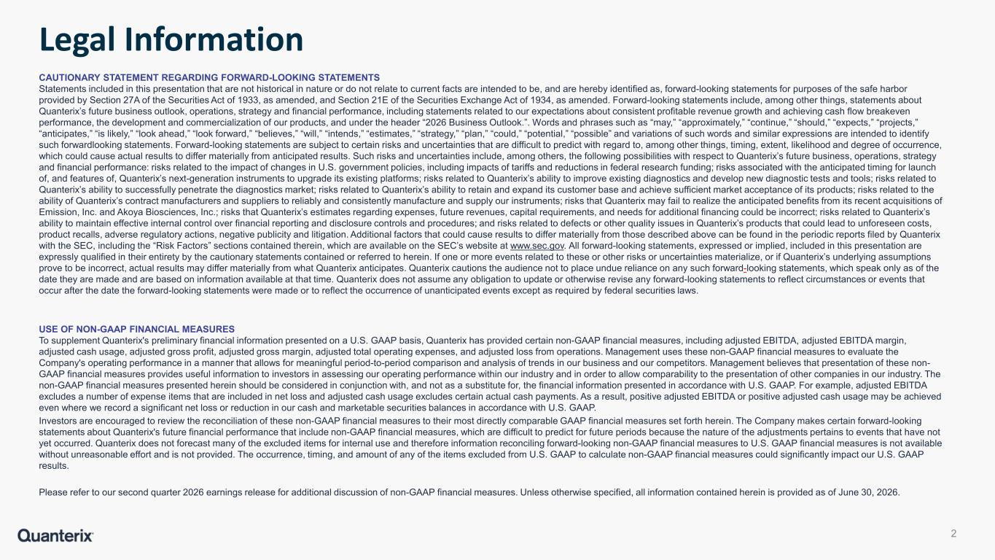
Legal Information CAUTIONARY STATEMENT REGARDING FORWARD-LOOKING STATEMENTS Statements included in this presentation that are not historical in nature or do not relate to current facts are intended to be, and are hereby identified as, forward-looking statements for purposes of the safe harbor provided by Section 27A of the Securities Act of 1933, as amended, and Section 21E of the Securities Exchange Act of 1934, as amended. Forward-looking statements include, among other things, statements about Quanterix’s future business outlook, operations, strategy and financial performance, including statements related to our expectations about consistent profitable revenue growth and achieving cash flow breakeven performance, the development and commercialization of our products, and under the header “2026 Business Outlook.”. Words and phrases such as “may,” “approximately,” “continue,” “should,” “expects,” “projects,” “anticipates,” “is likely,” “look ahead,” “look forward,” “believes,” “will,” “intends,” “estimates,” “strategy,” “plan,” “could,” “potential,” “possible” and variations of such words and similar expressions are intended to identify such forwardlooking statements. Forward-looking statements are subject to certain risks and uncertainties that are difficult to predict with regard to, among other things, timing, extent, likelihood and degree of occurrence, which could cause actual results to differ materially from anticipated results. Such risks and uncertainties include, among others, the following possibilities with respect to Quanterix’s future business, operations, strategy and financial performance: risks related to the impact of changes in U.S. government policies, including impacts of tariffs and reductions in federal research funding; risks associated with the anticipated timing for launch of, and features of, Quanterix’s next-generation instruments to upgrade its existing platforms; risks related to Quanterix’s ability to improve existing diagnostics and develop new diagnostic tests and tools; risks related to Quanterix’s ability to successfully penetrate the diagnostics market; risks related to Quanterix’s ability to retain and expand its customer base and achieve sufficient market acceptance of its products; risks related to the ability of Quanterix’s contract manufacturers and suppliers to reliably and consistently manufacture and supply our instruments; risks that Quanterix may fail to realize the anticipated benefits from its recent acquisitions of Emission, Inc. and Akoya Biosciences, Inc.; risks that Quanterix’s estimates regarding expenses, future revenues, capital requirements, and needs for additional financing could be incorrect; risks related to Quanterix’s ability to maintain effective internal control over financial reporting and disclosure controls and procedures; and risks related to defects or other quality issues in Quanterix’s products that could lead to unforeseen costs, product recalls, adverse regulatory actions, negative publicity and litigation. Additional factors that could cause results to differ materially from those described above can be found in the periodic reports filed by Quanterix with the SEC, including the “Risk Factors” sections contained therein, which are available on the SEC’s website at www.sec.gov. All forward-looking statements, expressed or implied, included in this presentation are expressly qualified in their entirety by the cautionary statements contained or referred to herein. If one or more events related to these or other risks or uncertainties materialize, or if Quanterix’s underlying assumptions prove to be incorrect, actual results may differ materially from what Quanterix anticipates. Quanterix cautions the audience not to place undue reliance on any such forward-looking statements, which speak only as of the date they are made and are based on information available at that time. Quanterix does not assume any obligation to update or otherwise revise any forward-looking statements to reflect circumstances or events that occur after the date the forward-looking statements were made or to reflect the occurrence of unanticipated events except as required by federal securities laws. USE OF NON-GAAP FINANCIAL MEASURES To supplement Quanterix's preliminary financial information presented on a U.S. GAAP basis, Quanterix has provided certain non-GAAP financial measures, including adjusted EBITDA, adjusted EBITDA margin, adjusted cash usage, adjusted gross profit, adjusted gross margin, adjusted total operating expenses, and adjusted loss from operations. Management uses these non-GAAP financial measures to evaluate the Company's operating performance in a manner that allows for meaningful period-to-period comparison and analysis of trends in our business and our competitors. Management believes that presentation of these non- GAAP financial measures provides useful information to investors in assessing our operating performance within our industry and in order to allow comparability to the presentation of other companies in our industry. The non-GAAP financial measures presented herein should be considered in conjunction with, and not as a substitute for, the financial information presented in accordance with U.S. GAAP. For example, adjusted EBITDA excludes a number of expense items that are included in net loss and adjusted cash usage excludes certain actual cash payments. As a result, positive adjusted EBITDA or positive adjusted cash usage may be achieved even where we record a significant net loss or reduction in our cash and marketable securities balances in accordance with U.S. GAAP. Investors are encouraged to review the reconciliation of these non-GAAP financial measures to their most directly comparable GAAP financial measures set forth herein. The Company makes certain forward-looking statements about Quanterix's future financial performance that include non-GAAP financial measures, which are difficult to predict for future periods because the nature of the adjustments pertains to events that have not yet occurred. Quanterix does not forecast many of the excluded items for internal use and therefore information reconciling forward-looking non-GAAP financial measures to U.S. GAAP financial measures is not available without unreasonable effort and is not provided. The occurrence, timing, and amount of any of the items excluded from U.S. GAAP to calculate non-GAAP financial measures could significantly impact our U.S. GAAP results. Please refer to our second quarter 2026 earnings release for additional discussion of non-GAAP financial measures. Unless otherwise specified, all information contained herein is provided as of June 30, 2026. 2

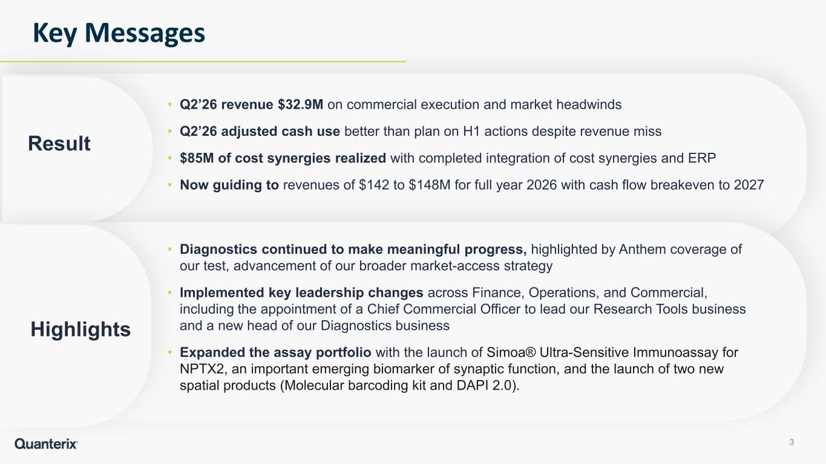
• Q2’26 revenue $32.9M on commercial execution and market headwinds • Q2’26 adjusted cash use better than plan on H1 actions despite revenue miss • $85M of cost synergies realized with completed integration of cost synergies and ERP • Now guiding to revenues of $142 to $148M for full year 2026 with cash flow breakeven to 2027 Key Messages 3 Result • Diagnostics continued to make meaningful progress, highlighted by Anthem coverage of our test, advancement of our broader market-access strategy • Implemented key leadership changes across Finance, Operations, and Commercial, including the appointment of a Chief Commercial Officer to lead our Research Tools business and a new head of our Diagnostics business • Expanded the assay portfolio with the launch of Simoa® Ultra-Sensitive Immunoassay for NPTX2, an important emerging biomarker of synaptic function, and the launch of two new spatial products (Molecular barcoding kit and DAPI 2.0). Highlights

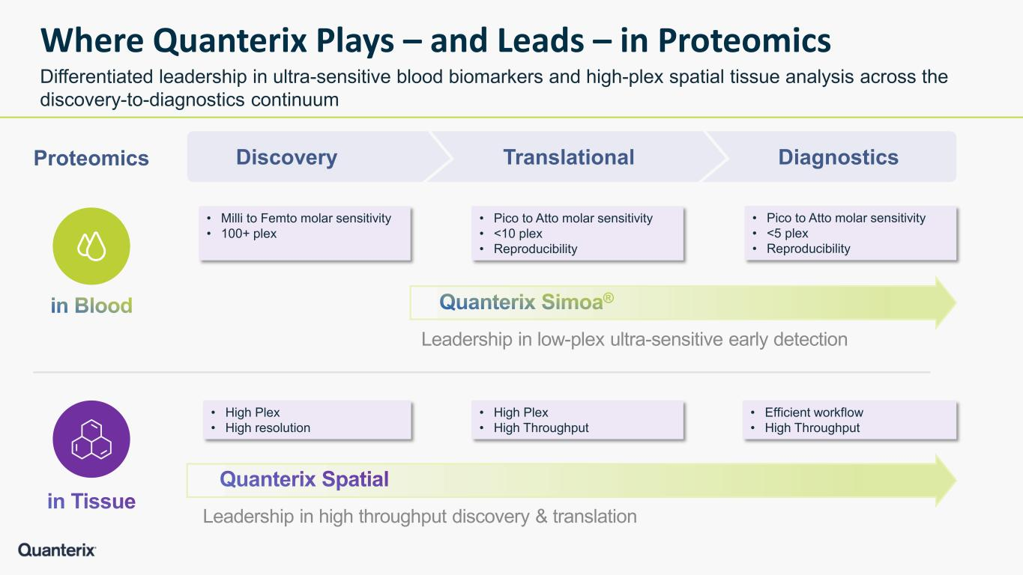
Where Quanterix Plays – and Leads – in Proteomics Differentiated leadership in ultra-sensitive blood biomarkers and high-plex spatial tissue analysis across the discovery-to-diagnostics continuum DiagnosticsTranslationalDiscovery • Milli to Femto molar sensitivity • 100+ plex • Pico to Atto molar sensitivity • <10 plex • Reproducibility • Pico to Atto molar sensitivity • <5 plex • Reproducibility Leadership in low-plex ultra-sensitive early detection • High Plex • High resolution • High Plex • High Throughput • Efficient workflow • High Throughput Leadership in high throughput discovery & translation Proteomics

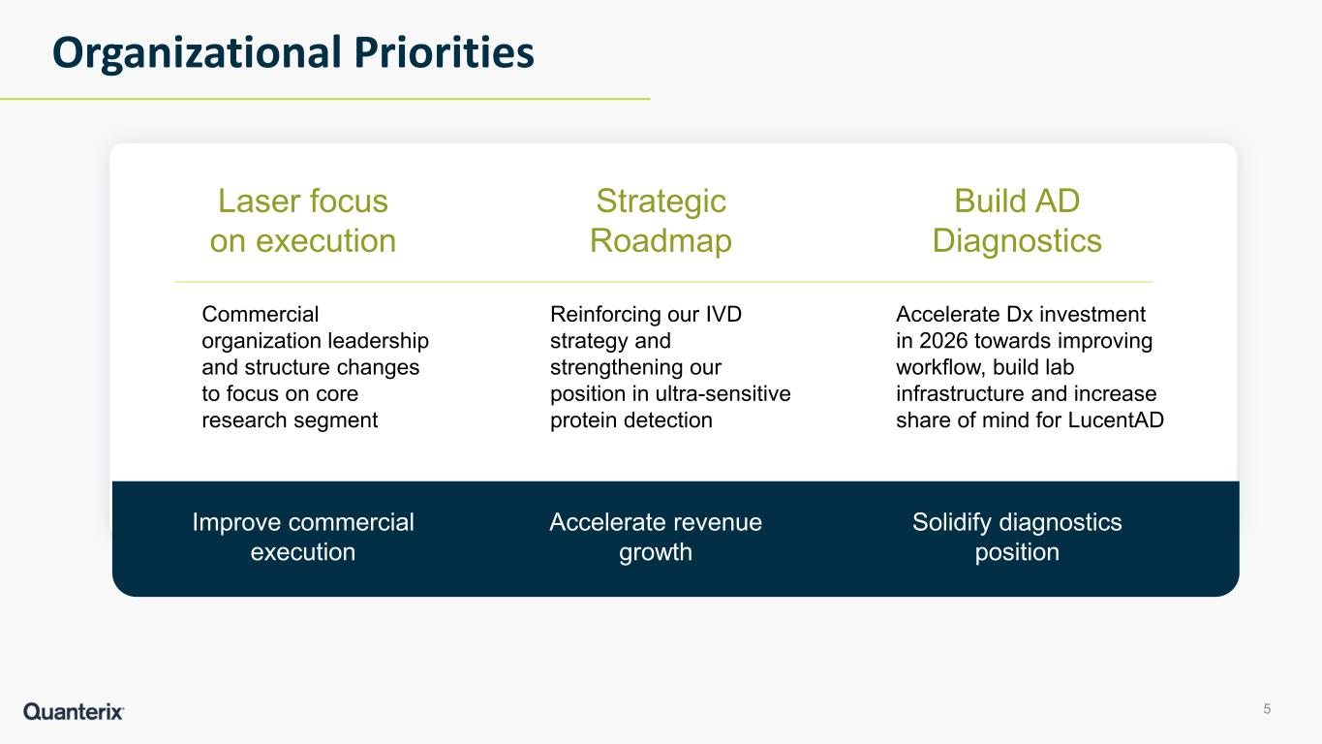
Organizational Priorities Laser focus on execution Commercial organization leadership and structure changes to focus on core research segment Strategic Roadmap Reinforcing our IVD strategy and strengthening our position in ultra-sensitive protein detection Build AD Diagnostics Accelerate Dx investment in 2026 towards improving workflow, build lab infrastructure and increase share of mind for LucentAD Improve commercial execution Solidify diagnostics position Accelerate revenue growth 5

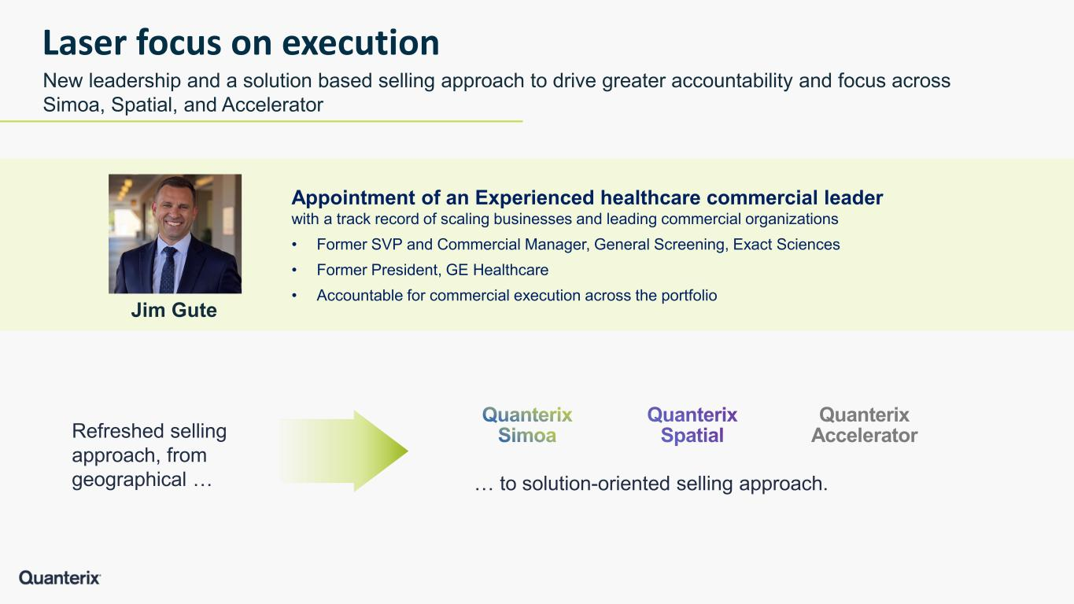
Appointment of an Experienced healthcare commercial leader with a track record of scaling businesses and leading commercial organizations • Former SVP and Commercial Manager, General Screening, Exact Sciences • Former President, GE Healthcare • Accountable for commercial execution across the portfolio Laser focus on execution New leadership and a solution based selling approach to drive greater accountability and focus across Simoa, Spatial, and Accelerator Quanterix Accelerator Jim Gute Refreshed selling approach, from geographical … … to solution-oriented selling approach.

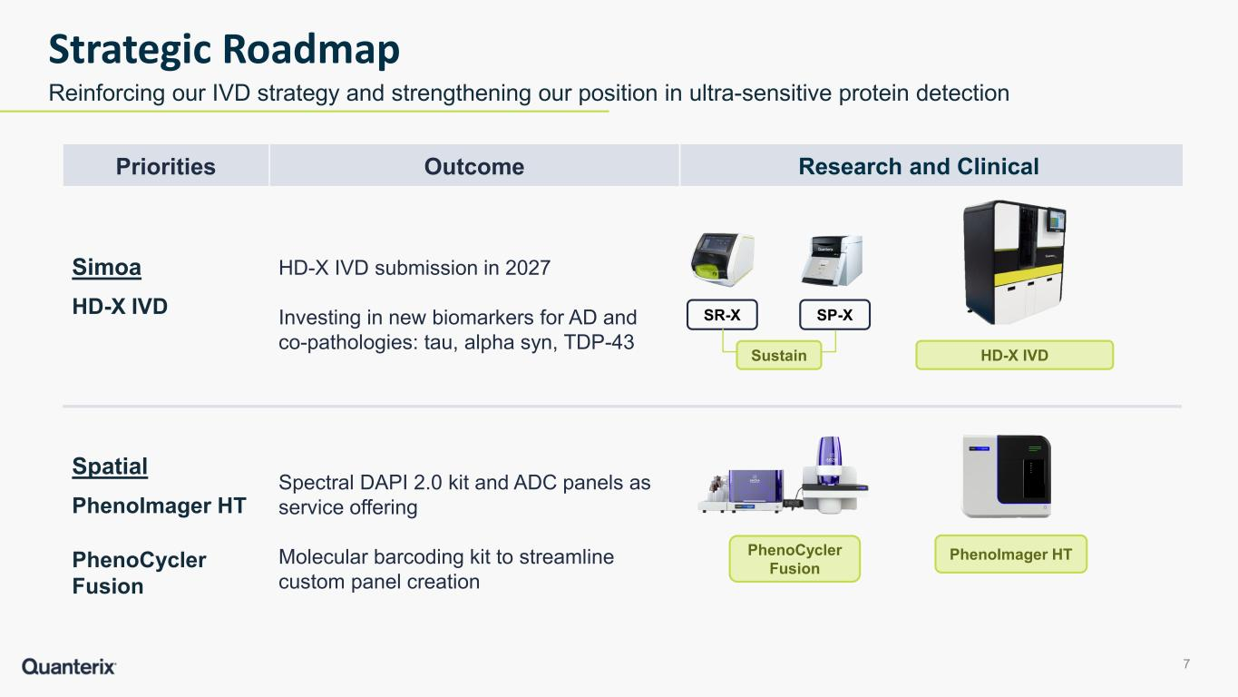
7 Strategic Roadmap Reinforcing our IVD strategy and strengthening our position in ultra-sensitive protein detection HD-X IVD SP-XSR-X Priorities Outcome Simoa HD-X IVD HD-X IVD submission in 2027 Investing in new biomarkers for AD and co-pathologies: tau, alpha syn, TDP-43 Spatial PhenoImager HT PhenoCycler Fusion Spectral DAPI 2.0 kit and ADC panels as service offering Molecular barcoding kit to streamline custom panel creation Research and Clinical PhenoImager HTPhenoCycler Fusion Sustain

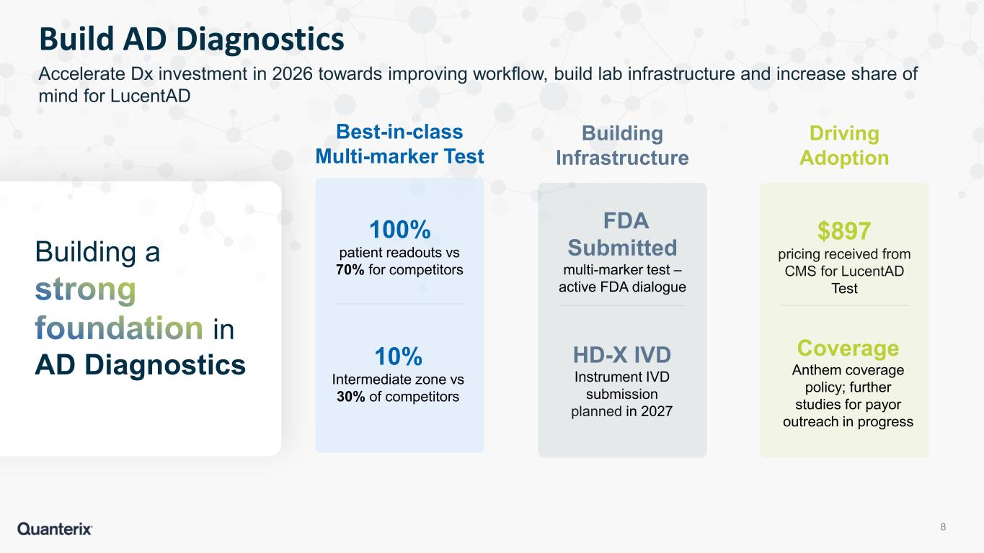
Best-in-class Multi-marker Test Building Infrastructure 100% patient readouts vs 70% for competitors 10% Intermediate zone vs 30% of competitors HD-X IVD Instrument IVD submission planned in 2027 Driving Adoption $897 pricing received from CMS for LucentAD Test Coverage Anthem coverage policy; further studies for payor outreach in progress FDA Submitted multi-marker test – active FDA dialogue Building a in AD Diagnostics 8 Build AD Diagnostics Accelerate Dx investment in 2026 towards improving workflow, build lab infrastructure and increase share of mind for LucentAD

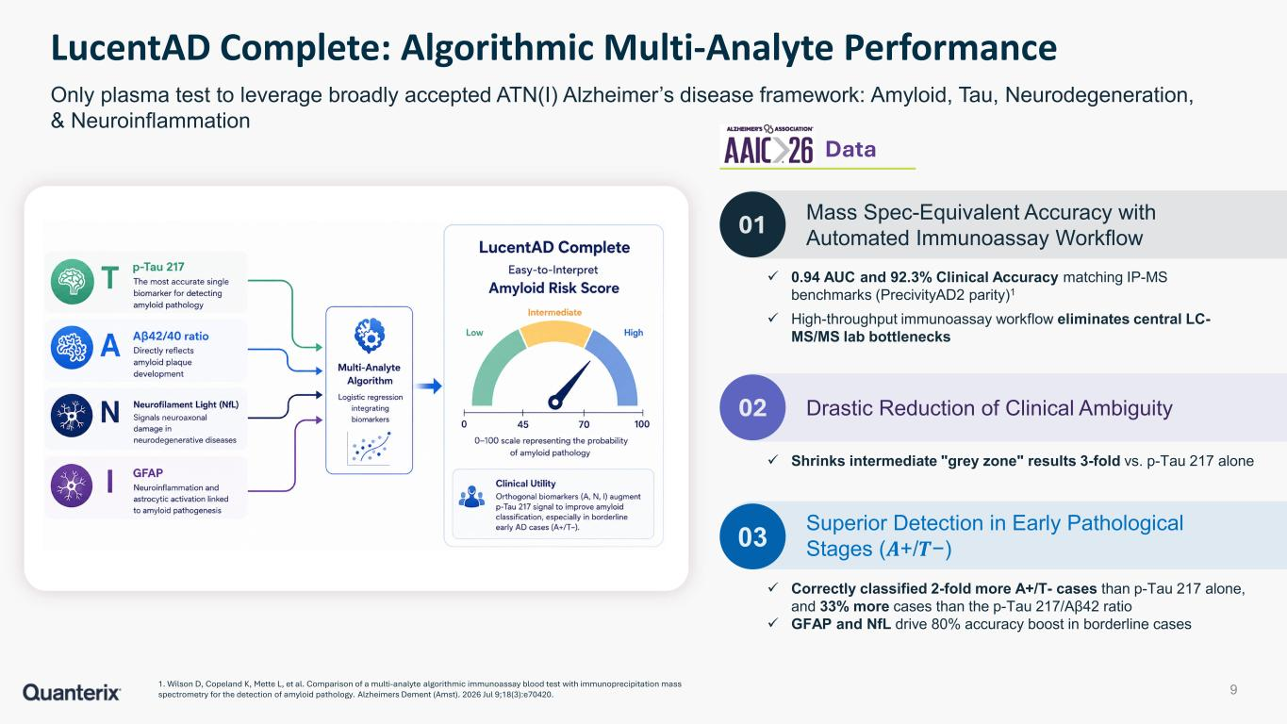
9 LucentAD Complete: Algorithmic Multi-Analyte Performance Only plasma test to leverage broadly accepted ATN(I) Alzheimer’s disease framework: Amyloid, Tau, Neurodegeneration, & Neuroinflammation 01 02 ✓ 0.94 AUC and 92.3% Clinical Accuracy matching IP-MS benchmarks (PrecivityAD2 parity)1 ✓ High-throughput immunoassay workflow eliminates central LC- MS/MS lab bottlenecks Mass Spec-Equivalent Accuracy with Automated Immunoassay Workflow Drastic Reduction of Clinical Ambiguity ✓ Shrinks intermediate "grey zone" results 3-fold vs. p-Tau 217 alone 03 Superior Detection in Early Pathological Stages (𝑨𝑨+/𝑻𝑻−) ✓ Correctly classified 2-fold more A+/T- cases than p-Tau 217 alone, and 33% more cases than the p-Tau 217/Aβ42 ratio ✓ GFAP and NfL drive 80% accuracy boost in borderline cases Data 1. Wilson D, Copeland K, Mette L, et al. Comparison of a multi-analyte algorithmic immunoassay blood test with immunoprecipitation mass spectrometry for the detection of amyloid pathology. Alzheimers Dement (Amst). 2026 Jul 9;18(3):e70420.

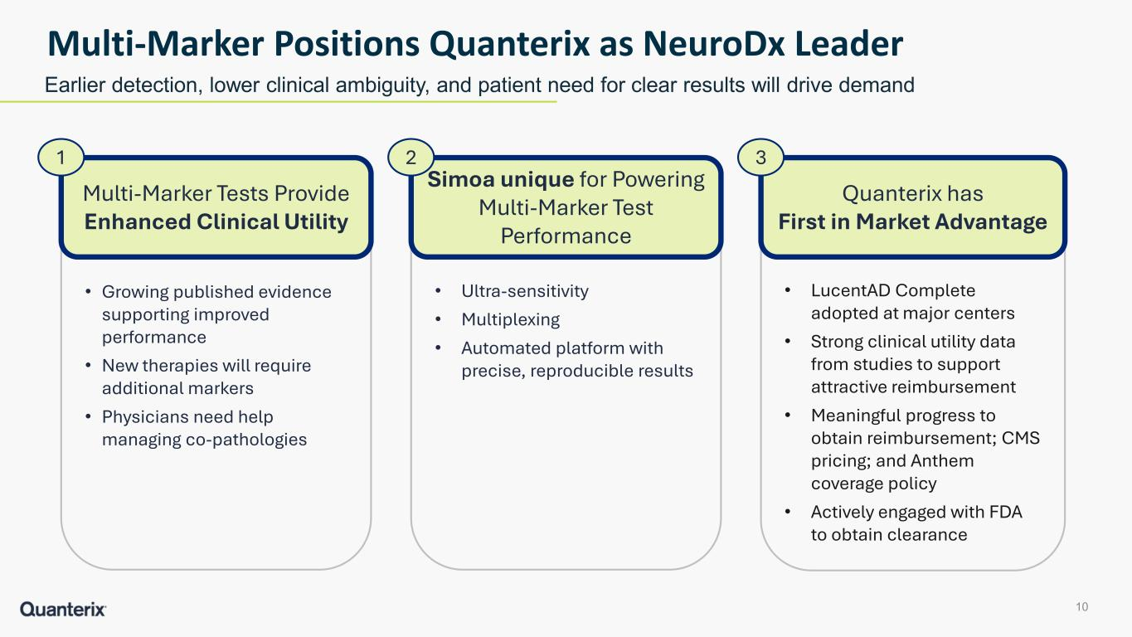
• Growing published evidence supporting improved performance • New therapies will require additional markers • Physicians need help managing co-pathologies 10 Multi-Marker Positions Quanterix as NeuroDx Leader Earlier detection, lower clinical ambiguity, and patient need for clear results will drive demand Multi-Marker Tests Provide Enhanced Clinical Utility 1 • Ultra-sensitivity • Multiplexing • Automated platform with precise, reproducible results Simoa unique for Powering Multi-Marker Test Performance 2 • LucentAD Complete adopted at major centers • Strong clinical utility data from studies to support attractive reimbursement • Meaningful progress to obtain reimbursement; CMS pricing; and Anthem coverage policy • Actively engaged with FDA to obtain clearance Quanterix has First in Market Advantage 3


Q2’26 Financial Update

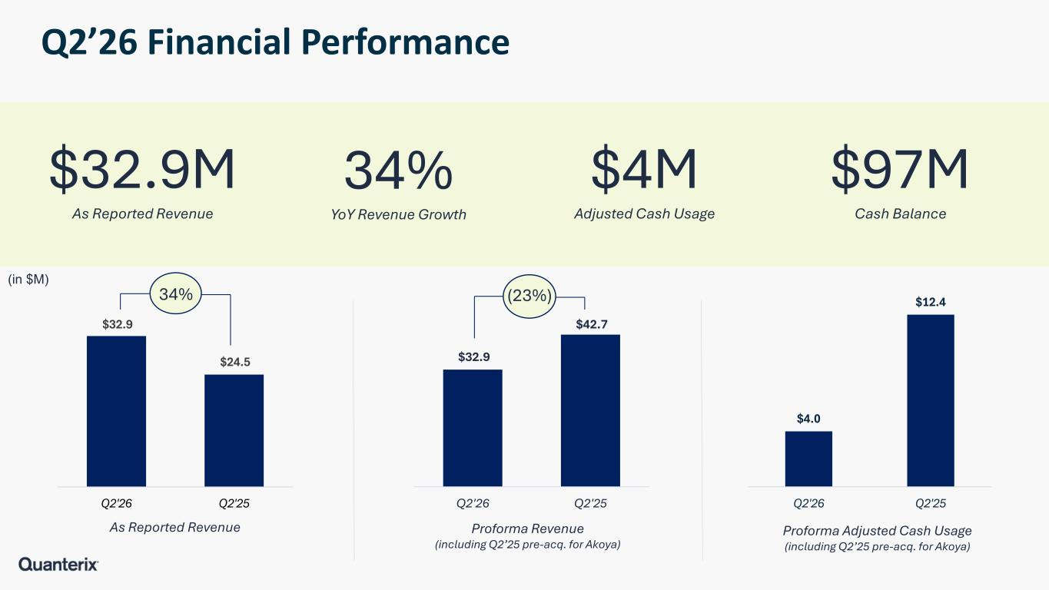
Q2’26 Financial Performance (in $M) $32.9M As Reported Revenue 34% YoY Revenue Growth $4M Adjusted Cash Usage $97M Cash Balance $32.9 $24.5 Q2'26 Q2'25 As Reported Revenue $32.9 $42.7 Q2'26 Q2'25 Proforma Revenue (including Q2’25 pre-acq. for Akoya) Proforma Adjusted Cash Usage (including Q2’25 pre-acq. for Akoya) (23%)34% $4.0 $12.4 Q2'26 Q2'25

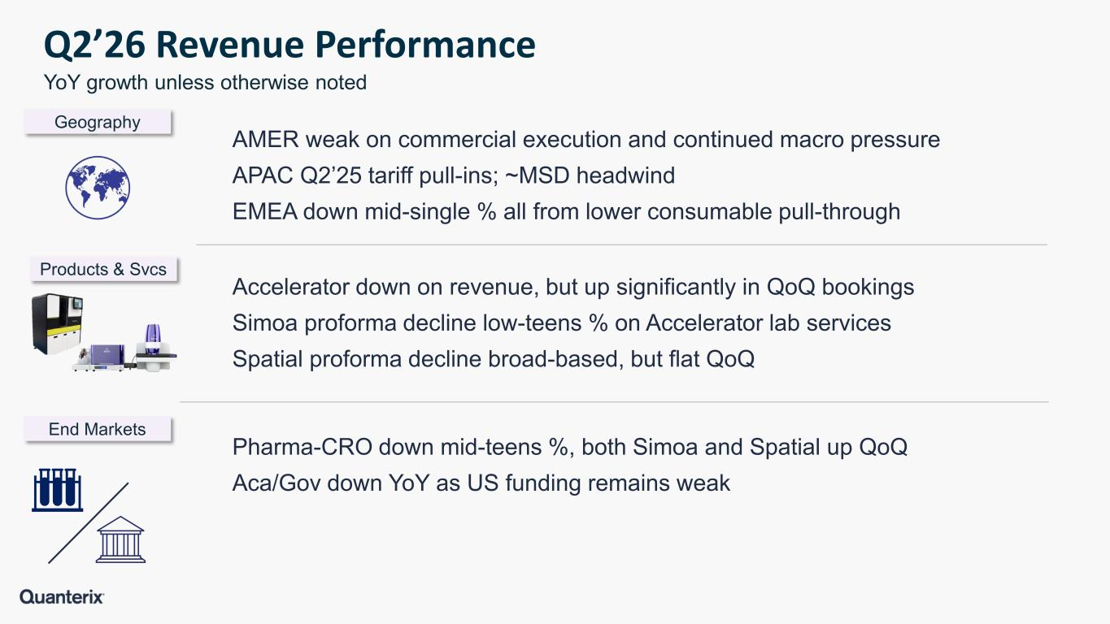
Q2’26 Revenue Performance AMER weak on commercial execution and continued macro pressure APAC Q2’25 tariff pull-ins; ~MSD headwind EMEA down mid-single % all from lower consumable pull-through Accelerator down on revenue, but up significantly in QoQ bookings Simoa proforma decline low-teens % on Accelerator lab services Spatial proforma decline broad-based, but flat QoQ Pharma-CRO down mid-teens %, both Simoa and Spatial up QoQ Aca/Gov down YoY as US funding remains weak Products & Svcs Geography End Markets YoY growth unless otherwise noted

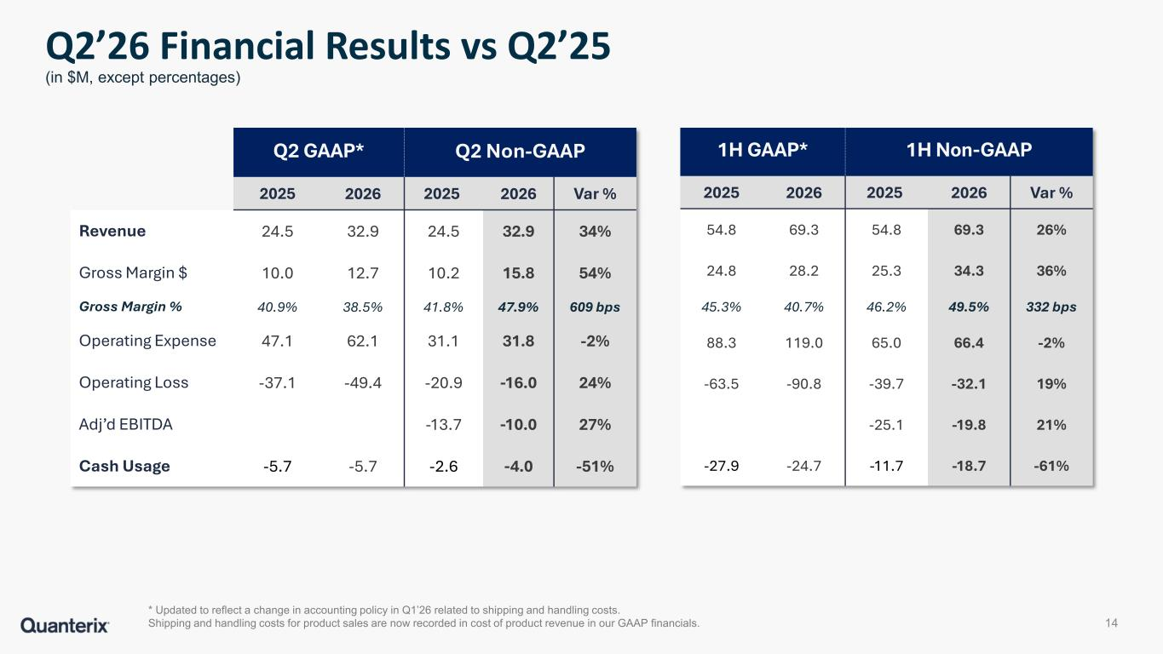
Q2 GAAP* Q2 Non-GAAP 2025 2026 2025 2026 Var % Revenue 24.5 32.9 24.5 32.9 34% Gross Margin $ 10.0 12.7 10.2 15.8 54% Gross Margin % 40.9% 38.5% 41.8% 47.9% 609 bps Operating Expense 47.1 62.1 31.1 31.8 -2% Operating Loss -37.1 -49.4 -20.9 -16.0 24% Adj’d EBITDA -13.7 -10.0 27% Cash Usage -5.7 -5.7 -2.6 -4.0 -51% * Updated to reflect a change in accounting policy in Q1’26 related to shipping and handling costs. Shipping and handling costs for product sales are now recorded in cost of product revenue in our GAAP financials. Q2’26 Financial Results vs Q2’25 (in $M, except percentages) 14 1H GAAP* 1H Non-GAAP 2025 2026 2025 2026 Var % 54.8 69.3 54.8 69.3 26% 24.8 28.2 25.3 34.3 36% 45.3% 40.7% 46.2% 49.5% 332 bps 88.3 119.0 65.0 66.4 -2% -63.5 -90.8 -39.7 -32.1 19% -25.1 -19.8 21% -27.9 -24.7 -11.7 -18.7 -61%

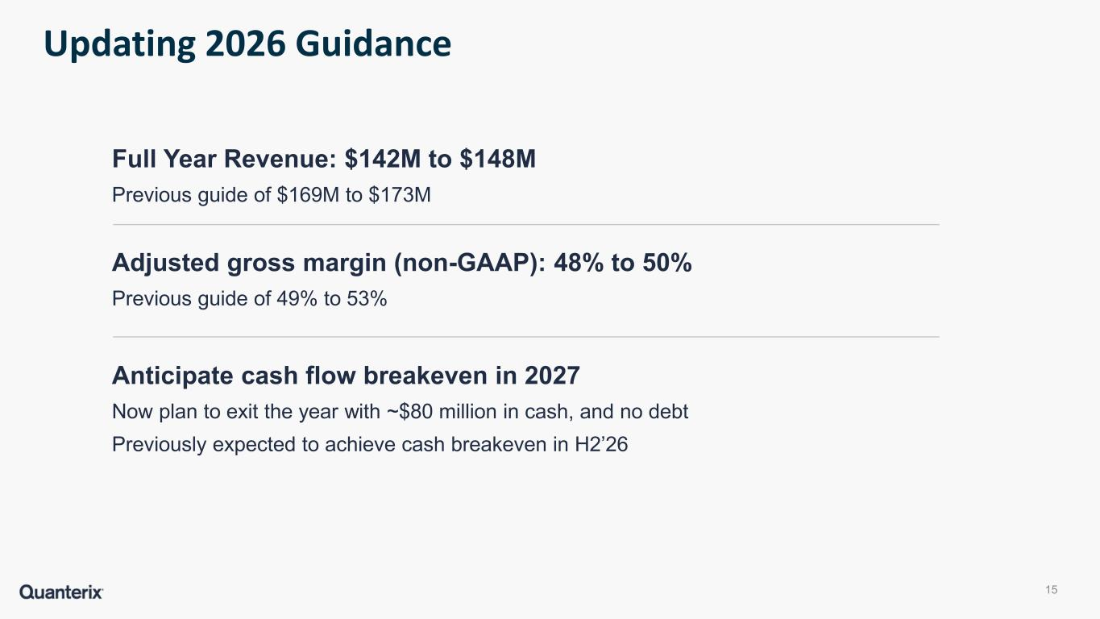
Full Year Revenue: $142M to $148M Previous guide of $169M to $173M Adjusted gross margin (non-GAAP): 48% to 50% Previous guide of 49% to 53% Anticipate cash flow breakeven in 2027 Now plan to exit the year with ~$80 million in cash, and no debt Previously expected to achieve cash breakeven in H2’26 Updating 2026 Guidance 15


Appendix

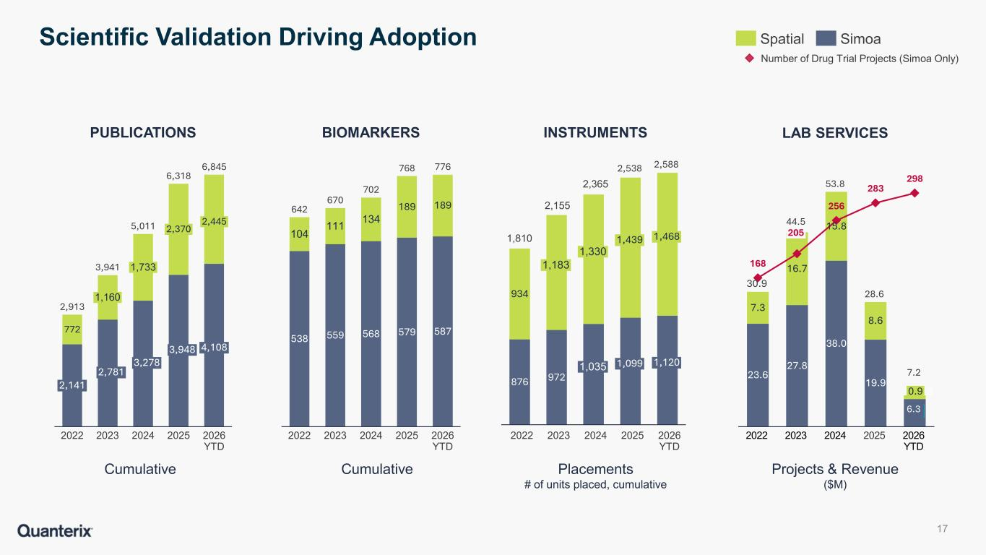
Spatial Simoa Number of Drug Trial Projects (Simoa Only) PUBLICATIONS BIOMARKERS INSTRUMENTS LAB SERVICES CumulativeCumulative Projects & Revenue ($M) Placements # of units placed, cumulative Scientific Validation Driving Adoption 17 772 2,141 2022 1,160 2023 1,733 2024 2,370 2025 2,445 4,108 2026 YTD 2,913 3,941 5,011 6,318 6,845 538 559 568 579 587 104 111 134 189 189 2022 2023 2024 2025 2026 YTD 642 670 702 768 776 2022 2023 2024 2025 2026 YTD 23.6 27.8 38.0 19.9 6.3 7.3 16.7 15.8 8.6 168 256 283 298 2022 205 2023 2024 2025 0.9 2026 YTD 30.9 44.5 53.8 28.6 6.3 2,781 3,278 3,948 876 972 934 1,183 1,330 1,035 1,439 1,099 1,468 1,120 1,810 2,155 2,365 2,538 2,588 7.2

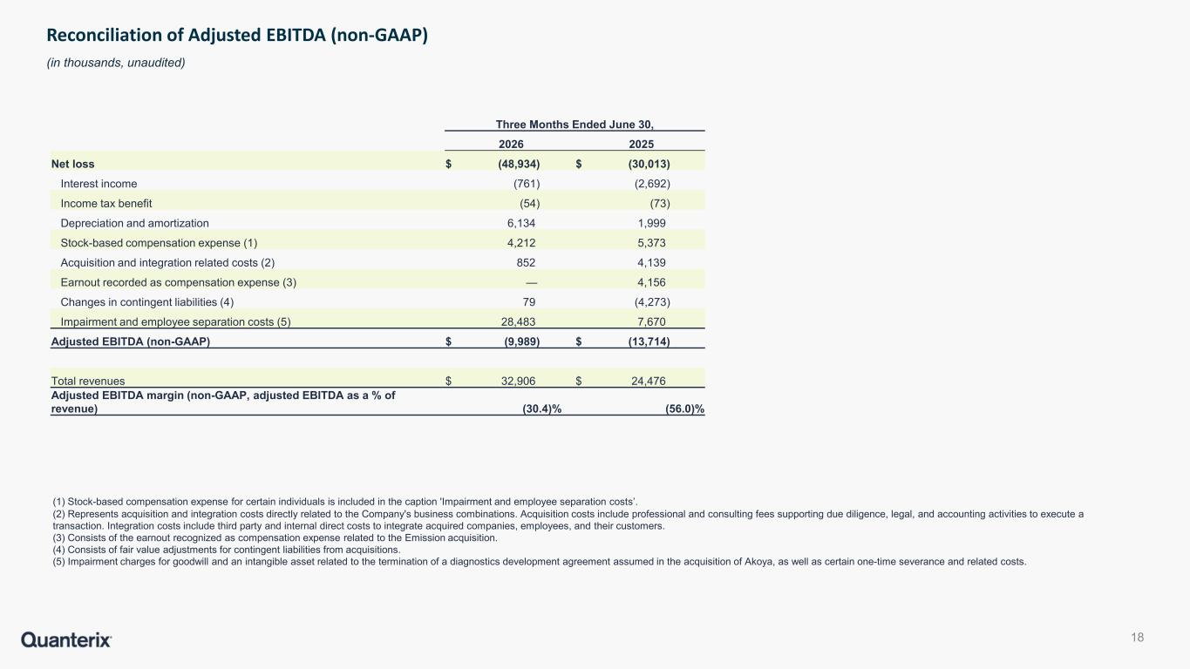
(1) Stock-based compensation expense for certain individuals is included in the caption 'Impairment and employee separation costs’. (2) Represents acquisition and integration costs directly related to the Company's business combinations. Acquisition costs include professional and consulting fees supporting due diligence, legal, and accounting activities to execute a transaction. Integration costs include third party and internal direct costs to integrate acquired companies, employees, and their customers. (3) Consists of the earnout recognized as compensation expense related to the Emission acquisition. (4) Consists of fair value adjustments for contingent liabilities from acquisitions. (5) Impairment charges for goodwill and an intangible asset related to the termination of a diagnostics development agreement assumed in the acquisition of Akoya, as well as certain one-time severance and related costs. Reconciliation of Adjusted EBITDA (non-GAAP) (in thousands, unaudited) 18 Three Months Ended June 30, 2026 2025 Net loss $ (48,934) $ (30,013) Interest income (761) (2,692) Income tax benefit (54) (73) Depreciation and amortization 6,134 1,999 Stock-based compensation expense (1) 4,212 5,373 Acquisition and integration related costs (2) 852 4,139 Earnout recorded as compensation expense (3) — 4,156 Changes in contingent liabilities (4) 79 (4,273) Impairment and employee separation costs (5) 28,483 7,670 Adjusted EBITDA (non-GAAP) $ (9,989) $ (13,714) Total revenues $ 32,906 $ 24,476 Adjusted EBITDA margin (non-GAAP, adjusted EBITDA as a % of revenue) (30.4)% (56.0)%

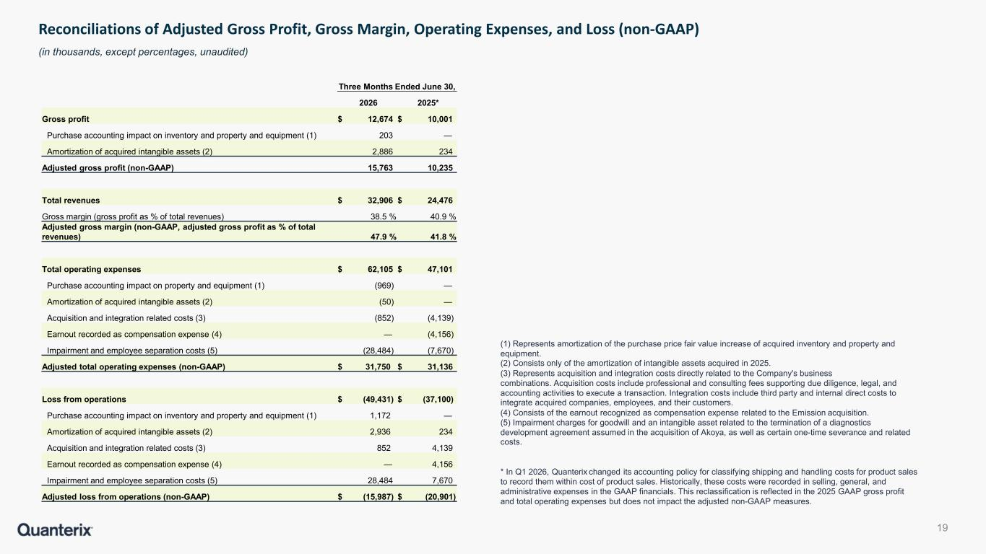
(1) Represents amortization of the purchase price fair value increase of acquired inventory and property and equipment. (2) Consists only of the amortization of intangible assets acquired in 2025. (3) Represents acquisition and integration costs directly related to the Company's business combinations. Acquisition costs include professional and consulting fees supporting due diligence, legal, and accounting activities to execute a transaction. Integration costs include third party and internal direct costs to integrate acquired companies, employees, and their customers. (4) Consists of the earnout recognized as compensation expense related to the Emission acquisition. (5) Impairment charges for goodwill and an intangible asset related to the termination of a diagnostics development agreement assumed in the acquisition of Akoya, as well as certain one-time severance and related costs. * In Q1 2026, Quanterix changed its accounting policy for classifying shipping and handling costs for product sales to record them within cost of product sales. Historically, these costs were recorded in selling, general, and administrative expenses in the GAAP financials. This reclassification is reflected in the 2025 GAAP gross profit and total operating expenses but does not impact the adjusted non-GAAP measures. Reconciliations of Adjusted Gross Profit, Gross Margin, Operating Expenses, and Loss (non-GAAP) (in thousands, except percentages, unaudited) 19 Three Months Ended June 30, 2026 2025* Gross profit $ 12,674 $ 10,001 Purchase accounting impact on inventory and property and equipment (1) 203 — Amortization of acquired intangible assets (2) 2,886 234 Adjusted gross profit (non-GAAP) 15,763 10,235 Total revenues $ 32,906 $ 24,476 Gross margin (gross profit as % of total revenues) 38.5 % 40.9 % Adjusted gross margin (non-GAAP, adjusted gross profit as % of total revenues) 47.9 % 41.8 % Total operating expenses $ 62,105 $ 47,101 Purchase accounting impact on property and equipment (1) (969) — Amortization of acquired intangible assets (2) (50) — Acquisition and integration related costs (3) (852) (4,139) Earnout recorded as compensation expense (4) — (4,156) Impairment and employee separation costs (5) (28,484) (7,670) Adjusted total operating expenses (non-GAAP) $ 31,750 $ 31,136 Loss from operations $ (49,431) $ (37,100) Purchase accounting impact on inventory and property and equipment (1) 1,172 — Amortization of acquired intangible assets (2) 2,936 234 Acquisition and integration related costs (3) 852 4,139 Earnout recorded as compensation expense (4) — 4,156 Impairment and employee separation costs (5) 28,484 7,670 Adjusted loss from operations (non-GAAP) $ (15,987) $ (20,901)

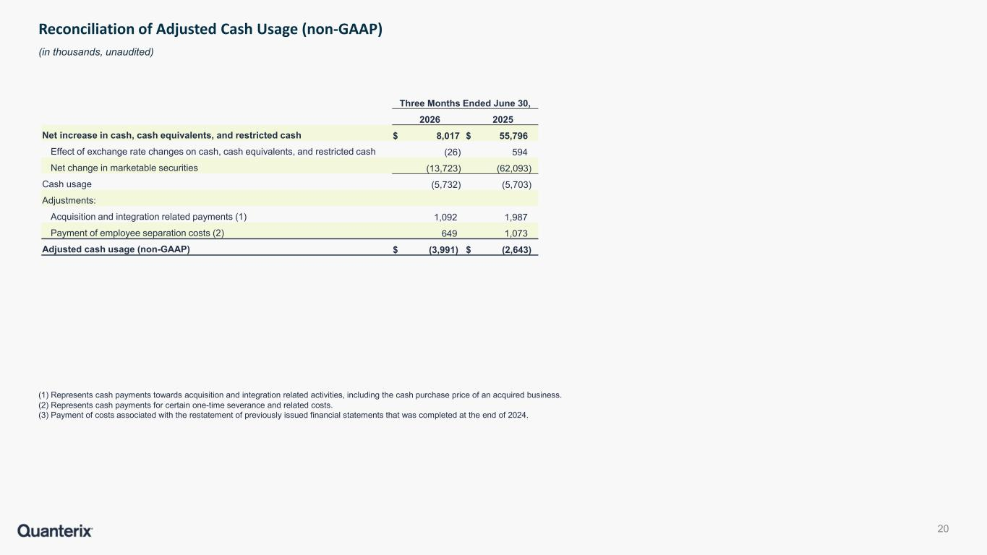
(1) Represents cash payments towards acquisition and integration related activities, including the cash purchase price of an acquired business. (2) Represents cash payments for certain one-time severance and related costs. (3) Payment of costs associated with the restatement of previously issued financial statements that was completed at the end of 2024. Reconciliation of Adjusted Cash Usage (non-GAAP) (in thousands, unaudited) 20 Three Months Ended June 30, 2026 2025 Net increase in cash, cash equivalents, and restricted cash $ 8,017 $ 55,796 Effect of exchange rate changes on cash, cash equivalents, and restricted cash (26) 594 Net change in marketable securities (13,723) (62,093) Cash usage (5,732) (5,703) Adjustments: Acquisition and integration related payments (1) 1,092 1,987 Payment of employee separation costs (2) 649 1,073 Adjusted cash usage (non-GAAP) $ (3,991) $ (2,643)


Contact Us General inquiries 900 Middlesex Turnpike, Billerica, MA 01821 USA 617.301.9400 info@quanterix.com www.quanterix.com

Quanterix Names Jim Gute Chief Commercial Officer
Brings 20 years of senior commercial leadership in healthcare and IT, including GE Healthcare and Exact Sciences
BILLERICA, Mass., August 10, 2026 -- Quanterix Corporation (Nasdaq: QTRX), a global leader in precision biomarker science, today announced that seasoned healthcare executive Jim Gute has been appointed Chief Commercial Officer of the company. In this role, he will lead a re-acceleration of growth within the company’s commercial operations.
“We are thrilled to attract commercial leadership of Jim’s caliber to Quanterix, at a pivotal time, ahead of our expansion in diagnostics and with renewed focus on growing our core business,” said Everett Cunningham, President & CEO of Quanterix. “Jim brings the expertise we need to deftly build upon our large installed base and increase new customers to our broadening offerings, leveraging our ultra-sensitive protein-detection in blood and high plex spatial analysis in tissue, that position us well across targeted translational work and diagnostics. His background at leading healthcare firms such as GE Healthcare and Exact Sciences prepares him well to tackle our commercial opportunities, improve our execution and drive growth.”
Mr. Gute most recently served as Senior Vice President and Commercial Manager, General Screening, at Exact Sciences, a company with nearly $3B in revenue prior to its acquisition in early 2026 by Abbott Labs, after a two-year period as General Manager, Western Region. He previously was President of GE Healthcare, having held a series of successively more responsible roles over 18 years with the organization. In all these roles, his focus has been on managing commercial teams to success, and designing and implementing solutions to improve performance, increase effectiveness and reduce costs for the enterprise, with strong leadership and executional results. He holds Bachelor of Arts and Masters of Arts degrees from Cleveland State University. He will be based at Quanterix’s Billerica, MA headquarters.
Added Mr. Gute, "I'm very excited to lead the commercial organization at Quanterix at this key moment when the company is preparing to ramp up its diagnostics business and re-energize its commercial activities to support its differentiated offerings in ultra-sensitive biomarker testing and spatial analysis. Our ability to accelerate growth across the business will benefit health outcomes, especially in the critical Alzheimer's disease market, and I'm enthusiastic about our opportunities for high impact here."
About Quanterix
Quanterix is a global leader in precision biomarker science, making biology measurable to deliver earlier insights and support breakthroughs in disease research, diagnostics, and drug development. Its Simoa® technology delivers industry-leading sensitivity, allowing researchers to detect and quantify biomarkers in blood and other fluids at concentrations far below traditional limits. Through the acquisition of Akoya Biosciences, Quanterix Spatial solutions deliver high-plex, quantitative protein analysis in tissue at single-cell resolution. Combined with Accelerator Laboratory services, Quanterix gives researchers the tools and expertise to translate discovery into precision diagnostics. Learn more at www.quanterix.com.
CAUTIONARY STATEMENT REGARDING FORWARD-LOOKING STATEMENTS
Statements included in this press release that are not historical in nature or do not relate to current facts are intended to be, and are hereby identified as, forward-looking statements for purposes of the safe harbor provided by Section 27A of the Securities Act of 1933, as amended, and Section 21E of the Securities Exchange Act of 1934, as amended. Forward-looking statements include, among other things, statements about the re-acceleration of growth within Quanterix’s commercial operations, Quanterix’s future business outlook, and the development and commercialization of new products. Words and phrases such as “may,” “approximately,” “continue,” “should,” “expects,” “projects,” “anticipates,” “is likely,” “look ahead,” “look forward,” “believes,” “will,” “intends,” “estimates,” “strategy,” “plan,” “could,” “potential,” “possible” and variations of such words and similar expressions are intended to identify such forward-looking statements. Forward-looking statements are subject to certain risks and uncertainties that are difficult to predict with regard to, among other things, timing, extent, likelihood and degree of occurrence, which could cause actual results to differ materially from anticipated results. Such risks and uncertainties include, among others, the following possibilities with respect to Quanterix’s future business,

operations, strategy and financial performance: risks related to the impact of changes in U.S. government policies, including impacts of tariffs and reductions in federal research funding; risks associated with the anticipated timing for launch of, and features of, Quanterix’s next-generation instruments to upgrade its existing platforms; risks related to Quanterix’s ability to improve existing diagnostics and develop new diagnostic tests and tools; risks related to Quanterix’s ability to successfully penetrate the diagnostics market; risks related to Quanterix’s ability to retain and expand its customer base and achieve sufficient market acceptance of its products; risks related to the ability of Quanterix’s contract manufacturers and suppliers to reliably and consistently manufacture and supply our instruments; risks that Quanterix may fail to realize the anticipated benefits and synergies of its recent acquisitions of Emission, Inc. and Akoya Biosciences Inc.; risk that integrating Quanterix’s business with that of Akoya could be more difficult, costly or time-consuming than expected; risks that Quanterix’s estimates regarding expenses, future revenues, capital requirements, and needs for additional financing could be incorrect; risks related to Quanterix’s ability to maintain effective internal control over financial reporting and disclosure controls and procedures; and risks related to defects or other quality issues in Quanterix’s products that could lead to unforeseen costs, product recalls, adverse regulatory actions, negative publicity and litigation. Additional factors that could cause results to differ materially from those described above can be found in the periodic reports filed by Quanterix with the SEC, including the “Risk Factors” sections contained therein, which are available on the SEC’s website at www.sec.gov.
All forward-looking statements, expressed or implied, included in this press release are expressly qualified in their entirety by the cautionary statements contained or referred to herein. If one or more events related to these or other risks or uncertainties materialize, or if Quanterix’s underlying assumptions prove to be incorrect, actual results may differ materially from what Quanterix anticipates. Quanterix cautions readers not to place undue reliance on any such forward-looking statements, which speak only as of the date they are made and are based on information available at that time. Quanterix does not assume any obligation to update or otherwise revise any forward-looking statements to reflect circumstances or events that occur after the date the forward-looking statements were made or to reflect the occurrence of unanticipated events except as required by federal securities laws.
Media
media@quanterix.com
Investor Relations
ir@quanterix.com

